
YouTestMe

Test-Taking Guide

Contents
1 Introduction 3
2 How to log in to the online proctored exam plateform 3
2.1 How to Retrieve Username and Password 3
2.1.1 Forgot username 3
2.1.2 Forgot password 4
2.2 Locating Your Username Reminder or Temporary Password Email 5
3 Exam requirements 5
4 Exam taking process 6
4.1 Exam technical support 8
4.2 Troubleshooting issues with the Equipment test 8
5 Exam Interface Overview: Tools and Navigation 8
5.1 Useful Links 9
6 Equipment Test 10
7 How to access my results 10
8 FAQ and Solved Issues 11
8.1 I can not share screen 11
8.2 I have trouble with face capturing 14
8.3 I have Microphone problem 14
8.4 I can not get my identification document to scan in the system 15
8.5 My Camera is not working 16
8.6 I have problem with usage of the external camera instead of build-in 16
8.7 "No Camera Available" notification when I am trying to connect camera on MacOS 18
8.8 “ No video from camera” issue 18
8.9 I use additional monitor instead of a laptop screen 19
8.10 My screen went black during the test 19
8.11 I can not start the test and get the window with the message to reconnect the proctoring session or continue test later 19
8.12 During the exam, the circle around my video occasionally lit up red and displayed the message "Found a similar profile." Should I be concerned? 20

Introduction
This document will guide you through the online proctored exam process on the YouTestMe GetCertified platform.

How to log in to the online proctored exam plateform
To take the proctored exam, please log in to the YouTestMe online examination platform at https://ara.youtestme.com/ using the username and password provided to you upon registering for the exam.

How to Retrieve Username and Password
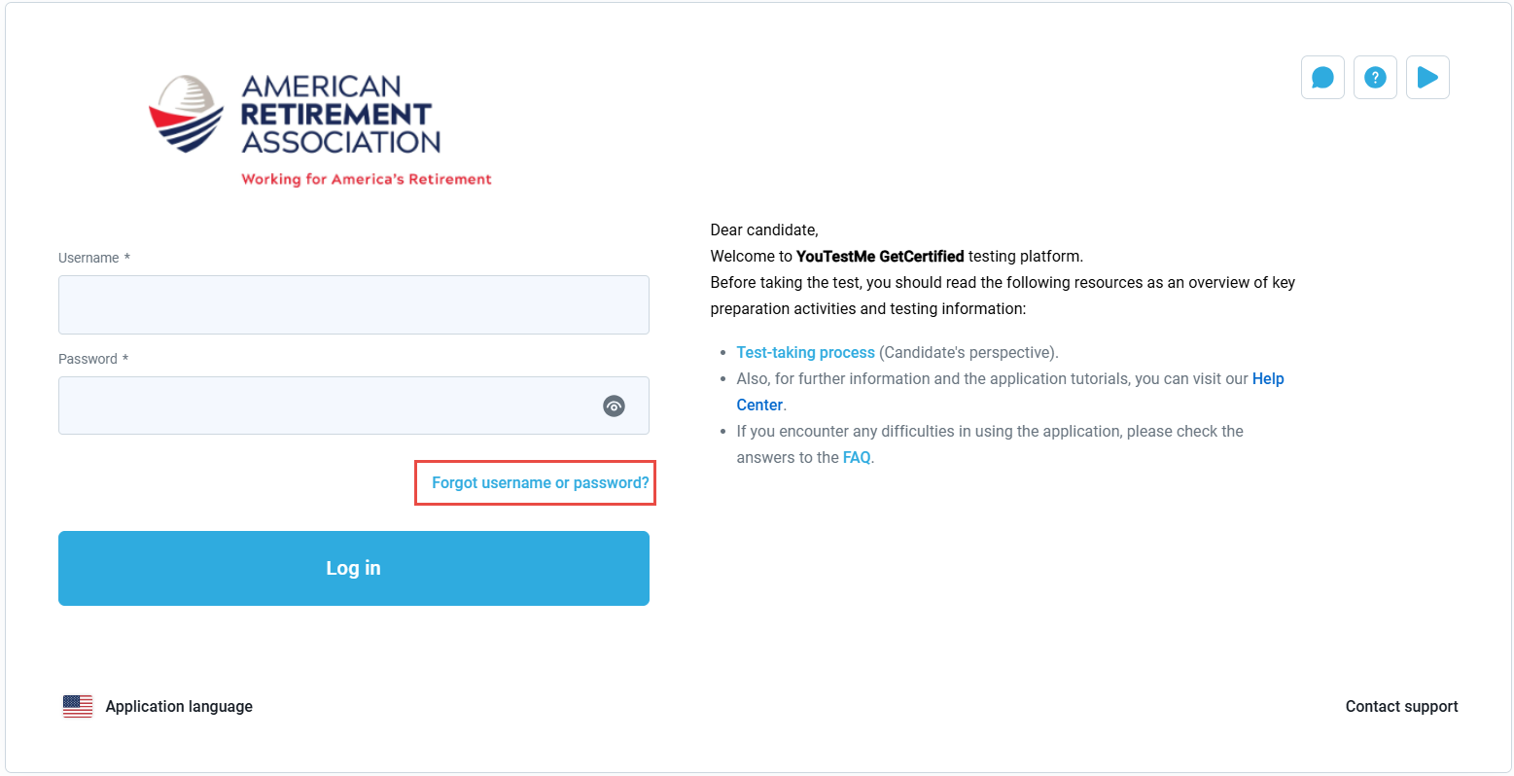
If you don't remember your username or password, an option is available on the login page to help you retrieve your username or request a temporary password to access your account.

Forgot username
To receive a username reminder via email, please enter the email address associated with your account in the designated field and click "Submit."
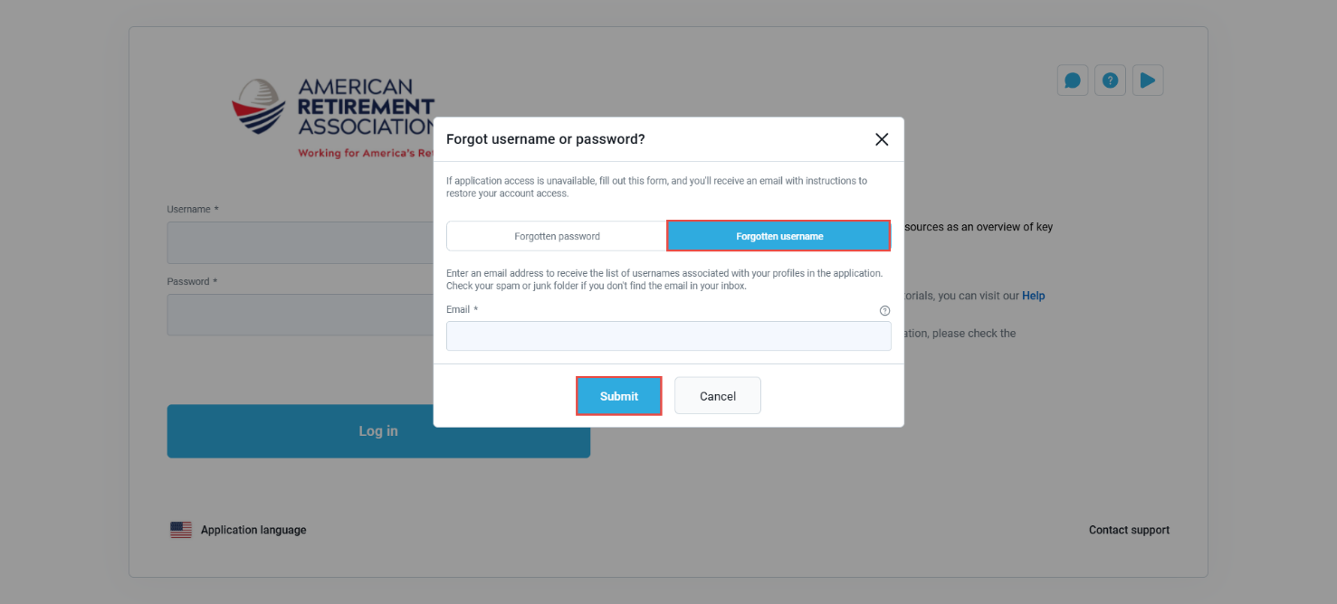
An email containing your username will be sent to the provided address, which you can use to log in.
Note: If you receive an empty email, it means the email address you provided is not associated with any account.

Forgot password
To receive a temporary password, please enter your username and the email address associated with your account, then click the "Submit" button. A temporary password will be sent to the provided email address.
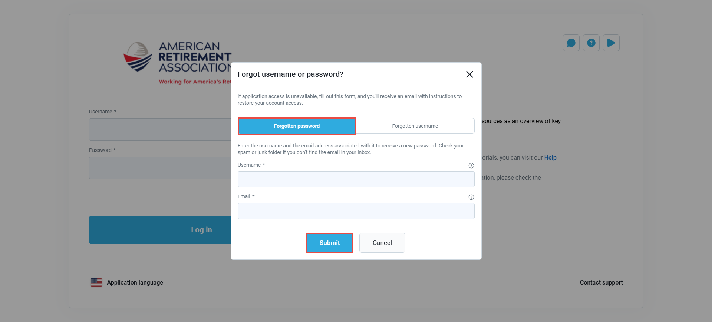
Upon logging in with the temporary password, you will be prompted to change your password. Use the new password to access your account going forward.
Note: If you request a temporary password multiple times, please ensure you use the most recent one.

Locating Your Username Reminder or Temporary Password Email
If you can't locate the requested email containing your username reminder or temporary password, please check your spam or junk folders, as the email may have been redirected there due to your email server's security settings.
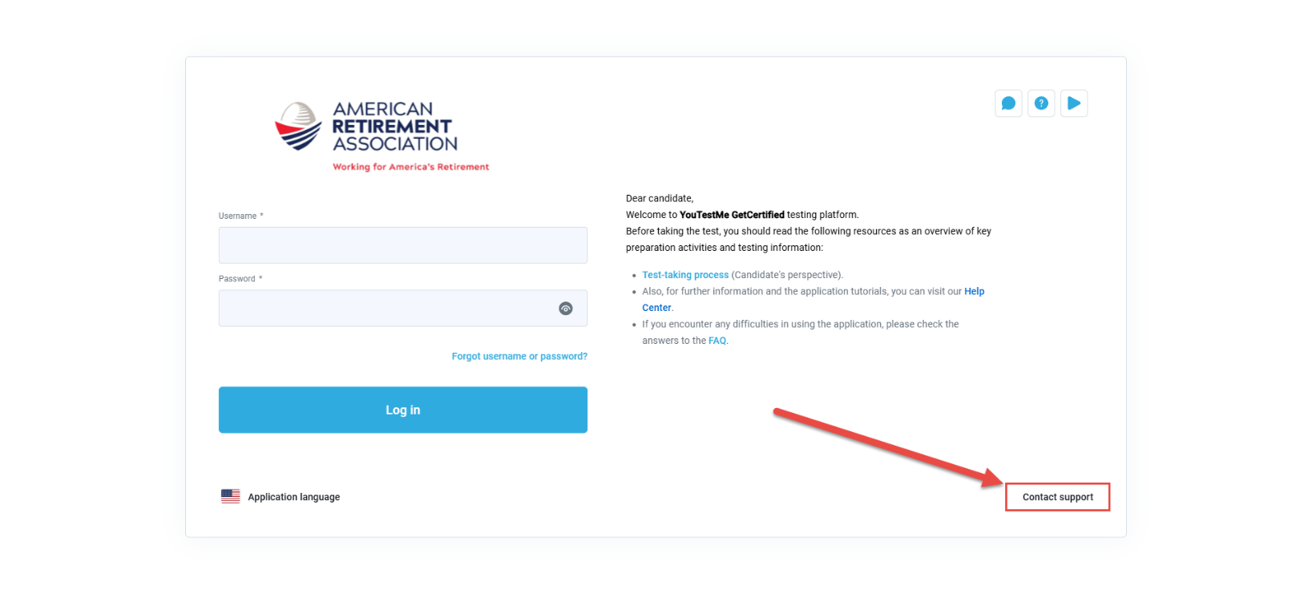
If you still can't find the email, please use the "Contact Support" option available on the login page or reach out to rpa@usaretirement.org for assistance.

Exam requirements
To start a successful exam session with online proctoring, you must have the following:
- A working camera
- A working microphone
- A stable and fast Internet connection
- Chrome or Firefox browser
Note: Google Chrome is recommended, Safari is currently not supported.
- A personal laptop or Desktop computer (Please do not use tablets or mobile phones to take the exam).
- A government issued identification document.
Note: please prepare a picture of your ID in the jpeg, jpg, or png format and save in your device’s library.
Outside interruptions may compromise your test-taking session. Keep in mind the following:
- The noise in the room where the test is to be taken should be reduced to the minimum. In the case of noise, Proctor will be notified of it.
- You should be the only person in front of your camera.
- You may not use other tabs.

Exam taking process
Please watch this instructional video for guidance.
The exam can be accessed under 'Assignments' – 'My Tests' and does not require booking a specific time slot.
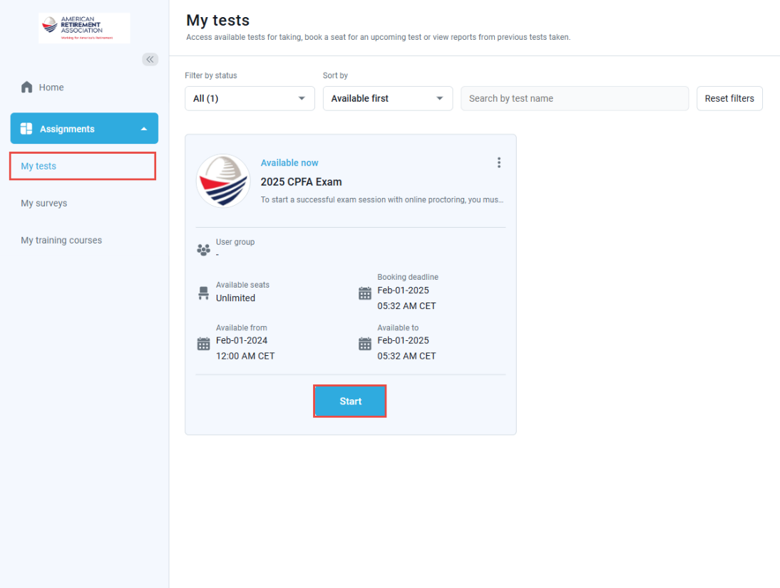
A popup dialog box with the exam instructions will be displayed and the “start” button will become clickable upon acknowledging the instructions.
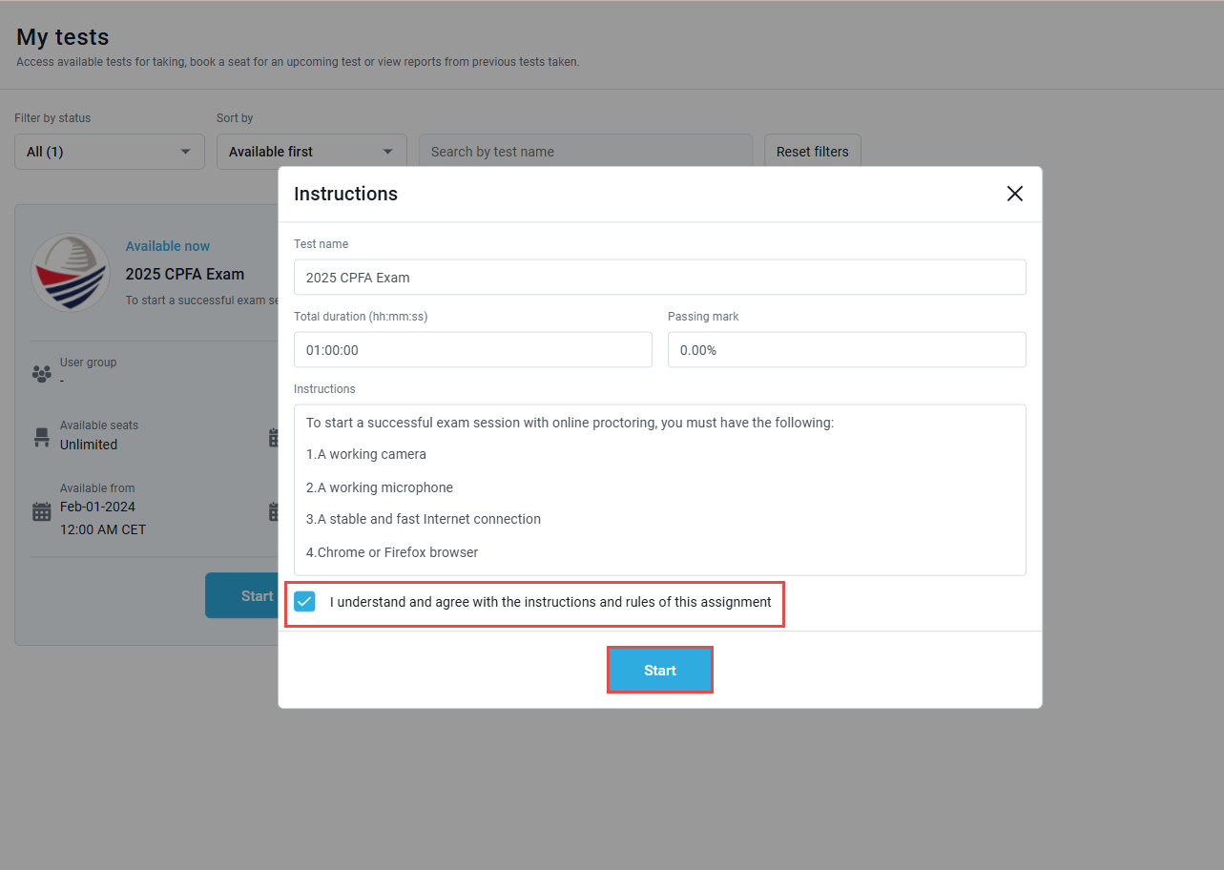
Once the "Start" button is clicked, the system will begin the equipment check, which will test the compatibility of your device and verify your identity through three steps:
Step 1: The system will check the compatibility of your browser, internet connection, and request permissions to use your camera and microphone. You will also be prompted to share your screen.
Note: You are required to share your entire screen.
Step 2: You will be asked to take a picture of your face.
Step 3: The system will prompt you to take or upload a picture of your ID.
Note: The ID picture should be horizontal, in JPEG, PNG, or JPG format, and not exceed 5 MB in size.
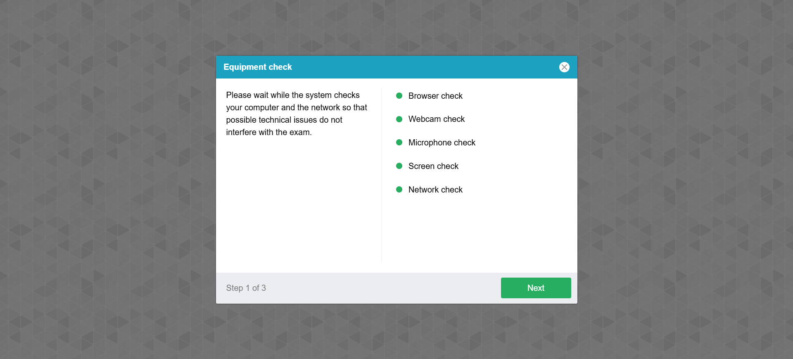

Exam technical support
If you encounter difficulties with any of the equipment check steps, please reach out to the YouTestMe exam support team for assistance:
Email address | support@youtestme.com
Phone number | +1 888 418 1718
Once you pass the equipment check steps, your exam will begin. The timer will start counting down only after you successfully complete the equipment check process.

Troubleshooting issues with the Equipment test
Issue with the Equipment test | Troubleshooting article
Screen Sharing | How to Troubleshoot Screen Sharing Issues.
Face capturing | How to Troubleshoot Face Capturing Issues During a Test.
ID scanning | How to Resolve Issues with ID Scanning.
Issue with Microphone | How to Troubleshoot Microphone Issues During a Proctored Exam.
Issue with Camera | How to Troubleshoot Camera Issues During a Proctored Exam.

Exam Interface Overview: Tools and Navigation
- Use this button to open the calculator.
- Use this button to open the notebook and take notes.
- Here you will be able to see your camera feed. The system will initiate warning messages whenever it detects violations, which will be displayed next to your video feed.
Note: The system might warn you about background noise, which could be a false alert (e.g., typing on the keyboard, taking the exam from an office, or having a pet nearby). As long as you follow the exam rules, you need not worry about these warnings.
- Here you can monitor the remaining time for the exam. The "Finish Exam" button and "Finish Section" button (for exams with sections) will be located just below the timer.
Note: Your answers are automatically saved as soon as you select an answer. When using the "Finish" button, you don’t need to worry about saving your answers. The system will alert you if a question has been skipped.
- Here you have access to the exam question list, where you can select a question to jump to it.
- You can mark questions for review using the flag button, and they will be added to your review list.
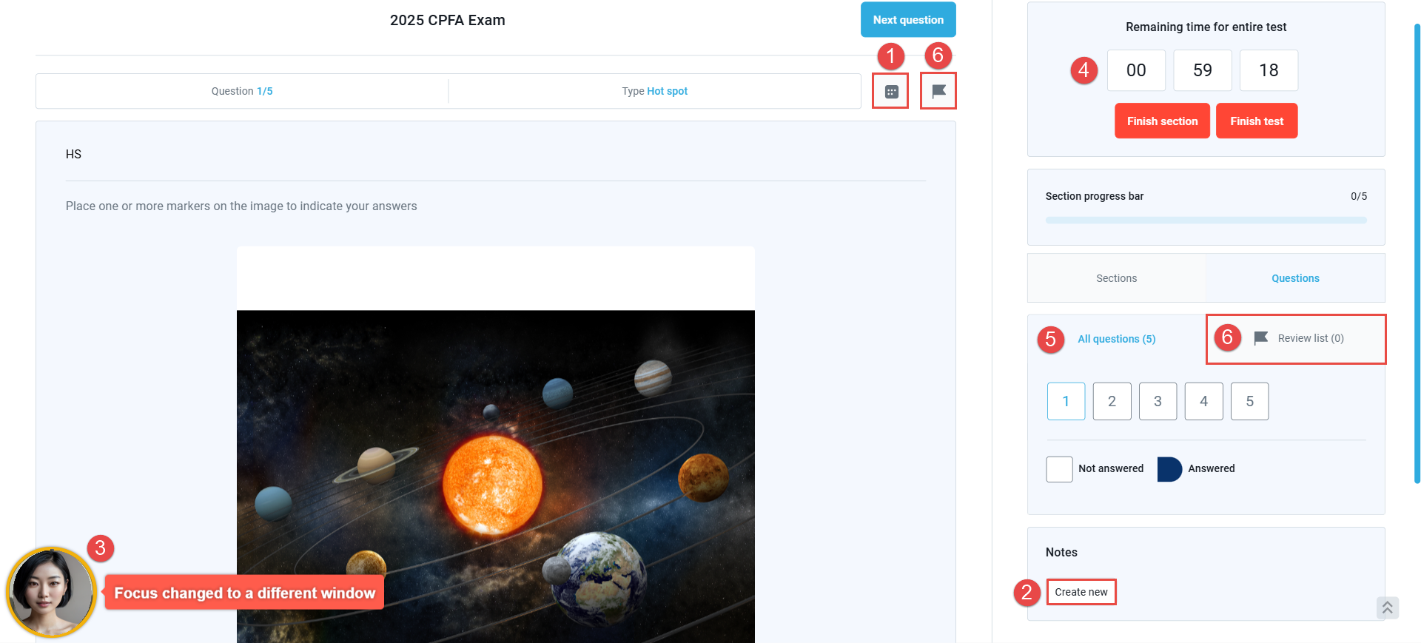
If the exam is open-book, any available attachments will be listed in the attachments section at the bottom of the exam page, and you can open them directly from there.

Useful Links
Link | Description
Claculator user manual | A guide on smoothly using the integrated calculator feature during the test.
PDF attachment user manual | A guide on accessing and using the PDF during your online exam.

ATTENTION – During the test-taking:
- Do not click the “Back” button on your browser
- Do not click the “X” button on your browser; to finish the test, use the “Finish test” button
- Do not click the “Finish test” button unless you are sure you have completed everything.
- Do not log out from the proctoring system during the test-taking.

Equipment Test
The Equipment Test is a demonstration test designed to help you test your equipment and familiarize yourself with the test-taking process.
This test should be completed before the actual exam to ensure your device is ready and to get comfortable with the exam features. Please note that the same device used for the equipment test must be used for the actual exam. If you change the device, camera, microphone, internet connection, or browser, you will need to retake the Equipment Test to avoid issues during the actual exam.
Note: This test will be available on the same page as the actual exam, and you can retake it as many times as necessary.
You can choose to hide the screen sharing notifications but don’t click “Stop sharing,” as it will result in your exam being invalid.
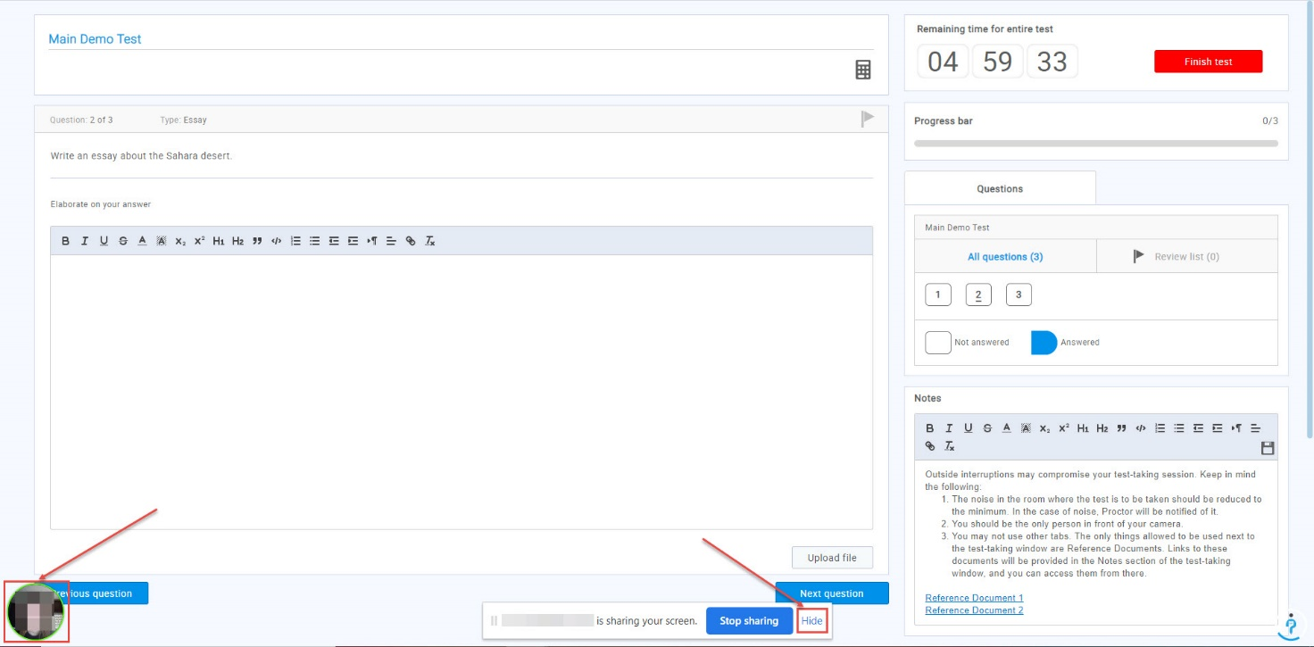

How to access my results
Once the results are available, you will be notified via email. You will then be invited to log in to your account to view your personal report and download your certificate if the exam is certified.
To preview the exam results, navigate to Assignments – My Tests.
- In the Filter by Status dropdown, select “Completed.”
- Click the Personal Report button to access your exam results.

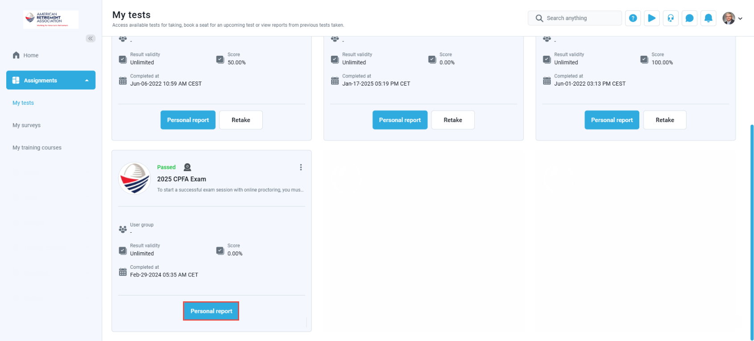
FAQ and Solved Issues

I can not share screen
The possible reasons:
- You are not sharing the entire screen.
- You are using an additional monitor.
- You are using MAC and did not give access to the computer for screen sharing.

Recommendation:
- Check which browser and OS you are using. If you use:
Chrome:
Once you are on the screen sharing screen, you will have to:
- Choose the entire screen.
- Click on the screen box
- Click on the button “share”
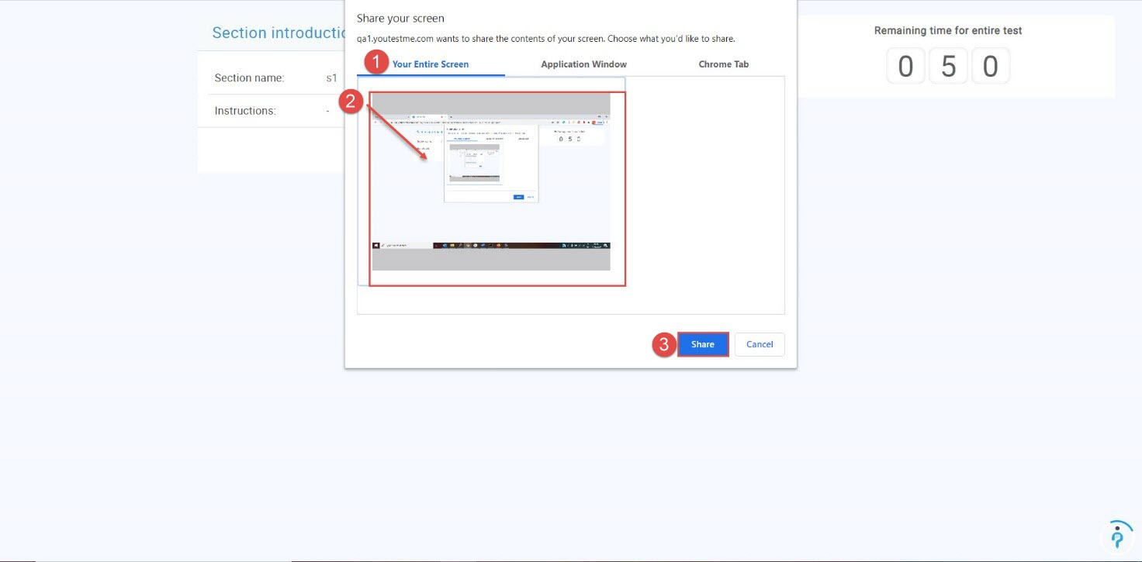

Once the equipment check is done, you will be prompted with the screen sharing option again, and you will have to follow the same steps above.

Please note that if you are using two monitors, sometimes you must unplug one to be able to choose the full-screen option.

Mozzila:
To be able to allow screen sharing on Mozilla Firefox, you need to click on the "Retry" button, and the new window will appear, where you should:
- Click on the "Select Window or Screen" dropdown.
Choose the "Entire screen" option

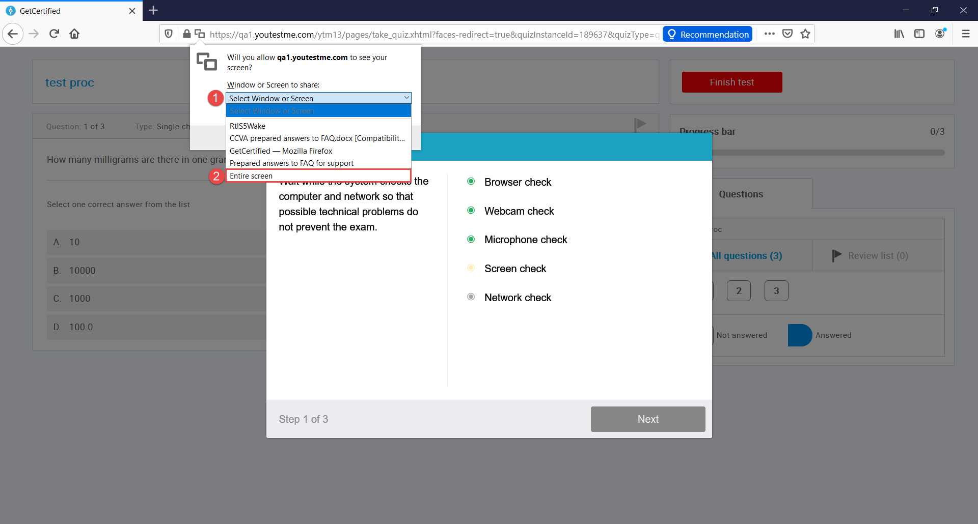

Click on “Allow” button to give permission for screen sharing.

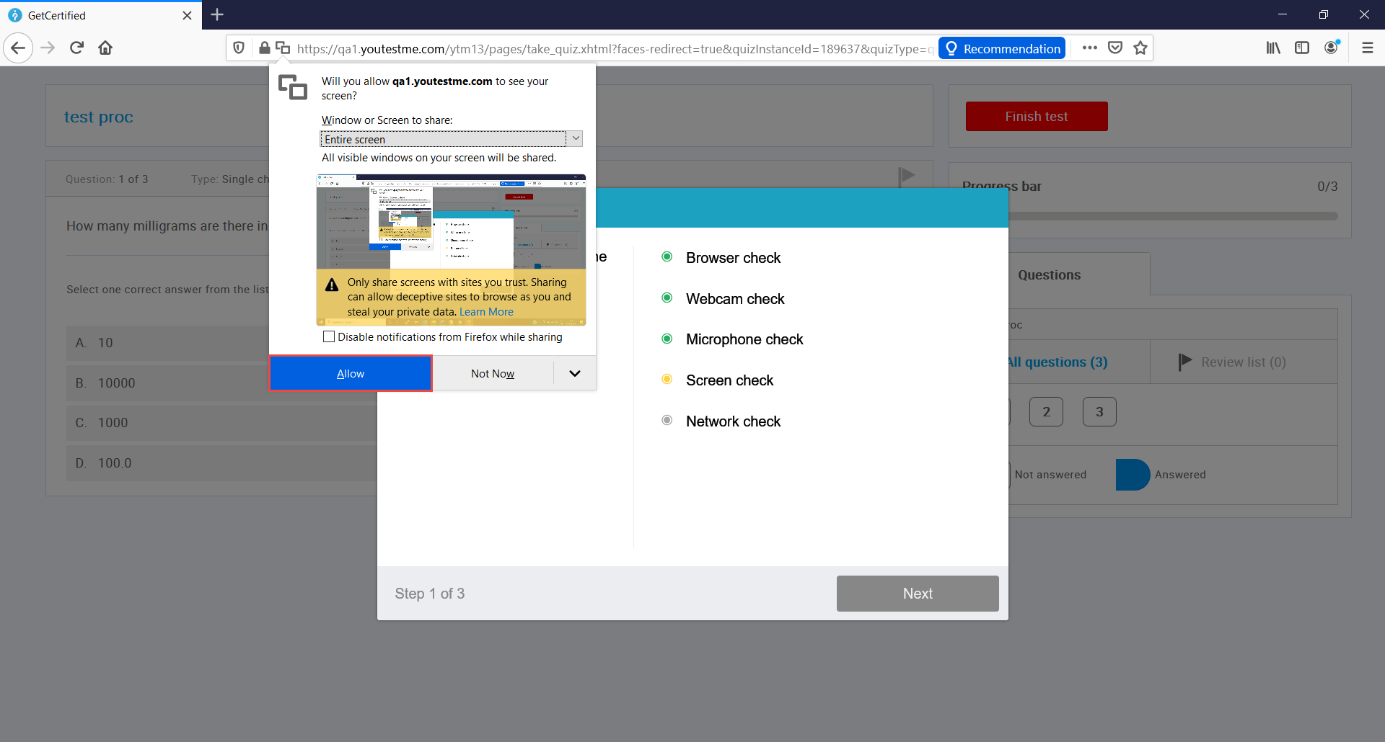

Kindly note that it is necessary to share the “Entire screen,” and if you are using the two screens, you will not be able to see that option. Please unplug one screen and then follow the instructions above.

Kindly note that it is necessary to share the “Entire screen,” and if you are using the two screens, you will not be able to see that option. Please unplug one screen and then follow the instructions above.

MAC:
The screen recording should be enabled. Read this instruction and check this instruction:

: https://www.youtestme.com/kb/how-to-enable-screen-sharing-for-the-proctored-test-on-mac/.

I have trouble with face capturing
Sometimes I experience problems where I cannot pass the face capturing step in the equipment check.

Recommendations:
Please ensure that your face fits into the frame on the screen and that there is enough light in the room. The glasses' reflection may also be a problem, so please try to take a photo without glasses if you are wearing them.
If that doesn't help, our additional recommendations are:
- Try to use another browser - Mozilla Firefox or Google Chrome.
- Also, you can check this link if you are a Mac user.

I have Microphone problem
Sometimes I experience problems with the microphone and can not pass the equipment check.

Recommendations:
- Confirm that access to the microphone is allowed in the browser.

Chrome:
- Click the three dots icon in the top right corner.
- Navigate to the “Settings”.
- On the left side, select “Security and Privacy”.
- Select “Site Settings”.
- Click on “Microphone” under the “Permissions” section.
- Confirm that the GC application is allowed to use your microphone. If not, select the GC application and allow microphone usage.

Mozilla:
- Click the three lines icon in the top right corner.
- Navigate to the “Settings”.
- On the left side, select “Privacy & Security”.
- Scroll the page and find microphone settings. Click on the “Settings” button.
- Confirm that the GC application is allowed to use your microphone. If not, select the GC application and allow microphone usage.

Note: If the Microphone is enabled in the browser but still does not work, please disable it and then enable it again!
- Allow microphone usage in the computer settings:
- In the search box in the bottom left corner, enter the microphone.
- Open Microphone privacy settings.
- Confirm that microphone usage is allowed.
- Scroll the page and confirm that microphone usage is permitted for the browser you are using for taking a test.

Note: Suggestion to use headphones or another computer.

I can not get my identification document to scan in the system
Suggestion1: Upload ID
Please try to take a photo of your ID using your mobile phone, then send it to your computer and upload a picture.

Suggestion 2: Two images on ID
If your ID has two pictures, please try to cover one picture and then try to take a picture.
If you want to upload a picture, we suggest cutting the small picture and trying to upload it that way. Please see examples below:
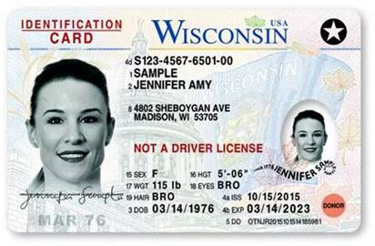

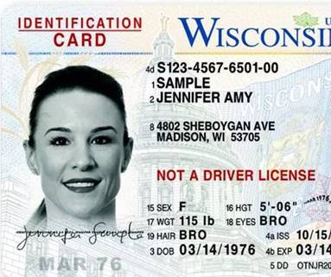
Suggestion 3: Taking a picture with an ID
If the picture is not clear enough for you, try to take a picture with your document (where your face will also be visible in the picture).

My Camera is not working
Sometimes I experience problems with the camera, and I cannot pass the equipment check.

Recommendations:
1. Confirm that access to the Camera is allowed in the browser.
Chrome:
- Click the three dots icon in the top right corner.
- Navigate to the “Settings”.
- On the left side, select “Security and Privacy”.
- Select “Site Settings”.
- Click on “Camera” under the “Permissions” section.
- Confirm that the GC application is allowed to use your Camera. If not, select the GC application and allow camera usage.

Mozilla:
- Click the three lines icon in the top right corner.
- Navigate to the “Settings”.
- On the left side, select “Privacy & Security”.
- Scroll the page and find camera settings. Click on the “Settings” button.
- Confirm that the GC application is allowed to use your Camera. If not, select the GC application and allow camera usage.

2. Allow camera usage in the computer settings:
- In the search box in the bottom left corner, enter Camera.
- Open Camera privacy settings.
- Confirm that camera usage is allowed.
- Scroll the page and confirm that camera usage is permitted for the browser you are using for taking a test.

Note: Suggestion to use an external Camera or another laptop.

I have problem with usage of the external camera instead of build-in
Recommendations:
- Computer settings:
Please try the following:
- Press Windows + X, and click Device Manager.
- Click Camera devices.
- Right-click on the integrated webcam.
- Click Disable.
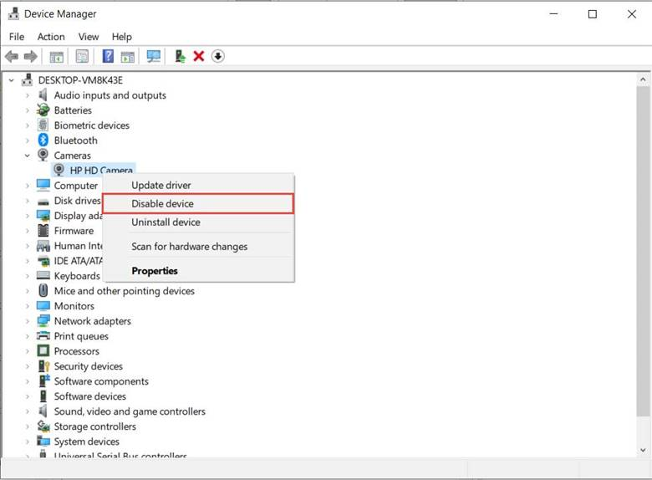
- Browser settings:
Chrome:
- Click the three dots icon in the top right corner.
- Navigate to the “Settings”.
- On the left side, select “Security and Privacy”.
- Select “Site Settings”.
- Click on “Camera” under the “Permissions” section.
- Choose the desired web camera.
Mozilla:
- Click the three lines icon in the top right corner.
- Navigate to the “Settings”.
- On the left side, select “Privacy & Security”.
- Scroll the page and find camera settings. Click on the “Settings” button.
- Choose the desired web camera.

"No Camera Available" notification when I am trying to connect camera on MacOS
- Check if the camera is working properly once more by using this link?
- If there are several webcams on your's computer, advise choosing the correct one in the browser settings. You can check this link for more information on how to do so.
- Refresh the computer if the webcam is working, but the error is still present.
- If the issue persists, you should follow the instructions advised at the following links:
- How To Fix The 'No Camera Available' Error In MacOS
- How to allow camera access
- Sometimes, for security reasons or when multiple applications use the camera, macOS users have limitations when connecting the camera to some sites. If nothing helps solve the issue, please use another computer or laptop.

“ No video from camera” issue
This error can appear because of the following reasons:
- The camera is not working
- The camera is reversed (showing back and not front)
- The camera has a cover
- The access to the camera is blocked by antivirus
- The driver is changed with the system update
Please check this video with the most common camera issues and their fixes https://www.youtube.com/watch?v=KOJHbJxiJZ8.

The camera reversed problem usually occurs on Microsoft Surface computers or external cameras since they can set the camera to back or front, and I am sending you a solution that you can try:

- Open Windows Device Manager (Right-click on the Windows menu and select Device Manager)
- Scroll down to System Devices; click to expand the menu.
- Double click on either Microsoft Camera Front or Microsoft Camera Rear
- Select Enable Device on the camera you want to use (front); Select Disable Device on the other.
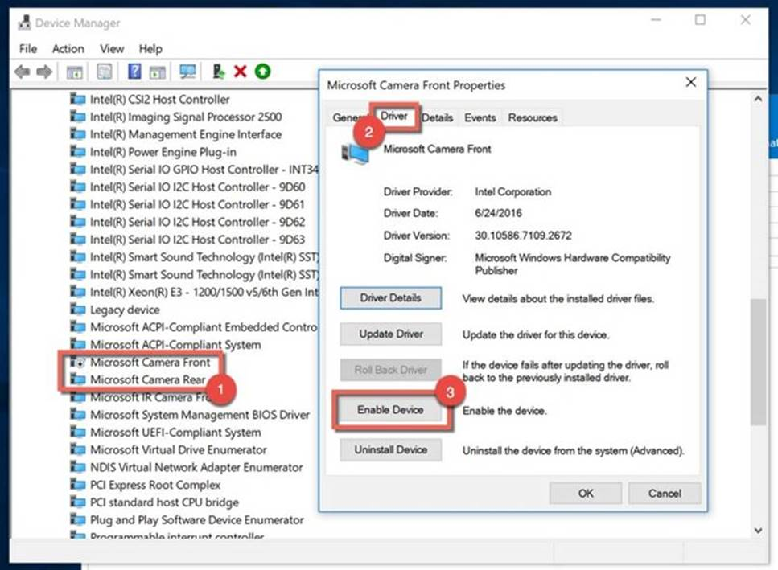

I use additional monitor instead of a laptop screen
For some of you, it is easier to use larger monitors instead of laptop screens, but if it is not allowed, you have to turn off an additional monitor and switch the test to the laptop screen.

Suggest to you the following:
- Move the browser window to the laptop screen.
- Click the Stop sharing button at the bottom of the page.
- Turn off and unplug the second monitor.
- The sharing window will appear. Choose to share the entire screen.

My screen went black during the test
The problem could be with your computer.
Here you can find the minimum system requirements for running Google Chrome.
Also, you could have experienced a known black screen Chrome issue, usually a sign of an unusual graphics display error.
There are multiple suggestions on how to solve this issue, and here is a link where you can find a few of them: https://www.lifewire.com/fix-google-chrome-black-screen-4590373.

I can not start the test and get the window with the message to reconnect the proctoring session or continue test later
- Check that ad-blockers and antiviruses are disabled.
- Extensions in the browsers, such as AdBlock or VPN, can cause the problem. Also, using a proxy server can cause the issue. Please disable all browser extensions or try a different browser, and do not use/disable proxies or VPNs.
- Try accessing the test using another computer and from a different location and network.

During the exam, the circle around my video occasionally lit up red and displayed the message "Found a similar profile." Should I be concerned?
No, you should not be overly concerned. This message appears when the system detects a potential match with another profile, which could happen due to lighting, facial angles, or other environmental factors. As long as you are following the exam rules and procedures, this notification does not indicate an issue on your part. If you have any concerns, you can contact the support team for clarification.

